Steps to create a MUSC Health Virtual Care account

- Navigate to musc.care
- This will launch MUSC Health Virtual Care.
- Follow the directions below, clicking as directed within the application.

- Click Create Account

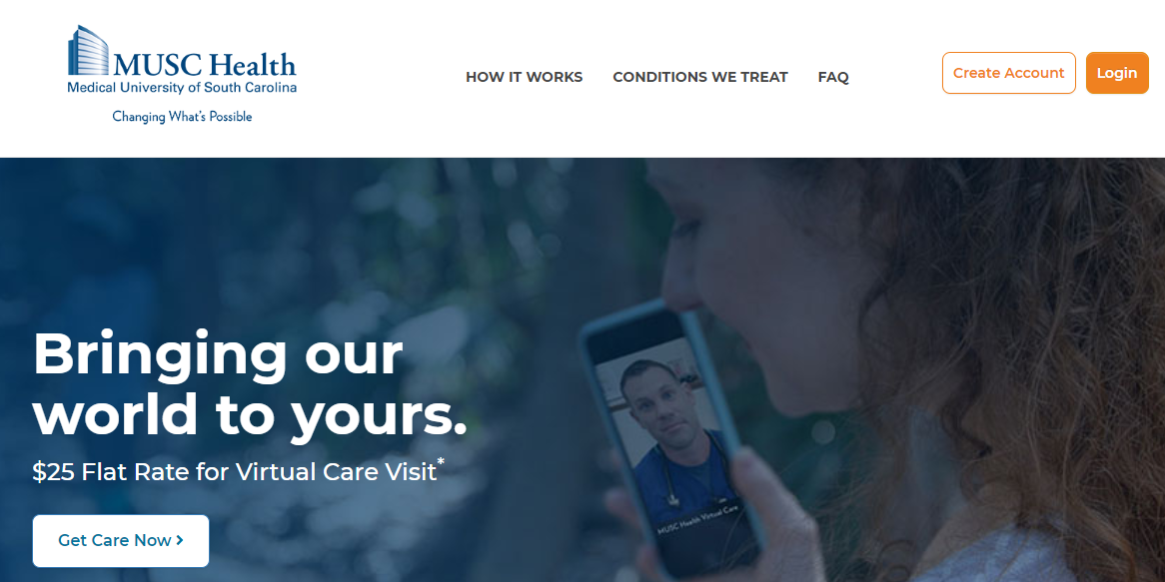

- The following screen will appear. Click Create Account again.

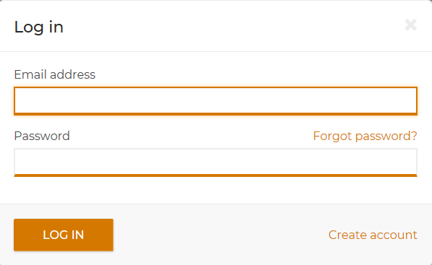

- Next, if you are a part of one of the available groups, select the appropriate circle and click Continue.

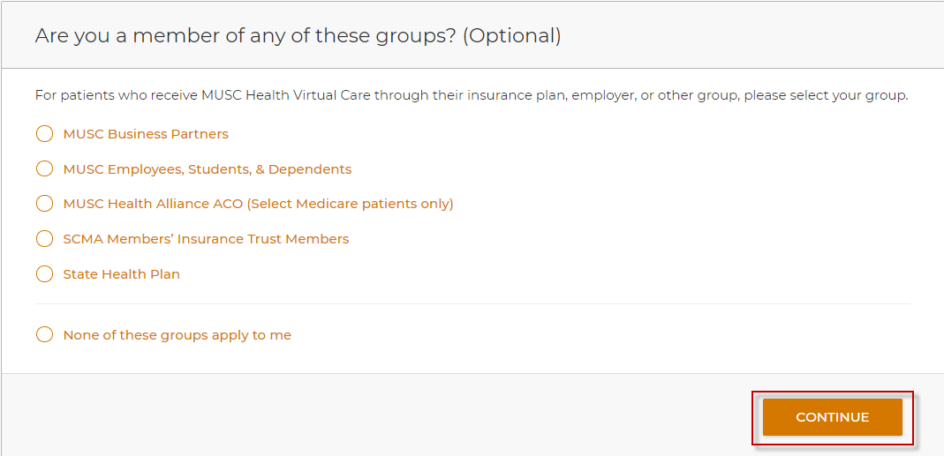

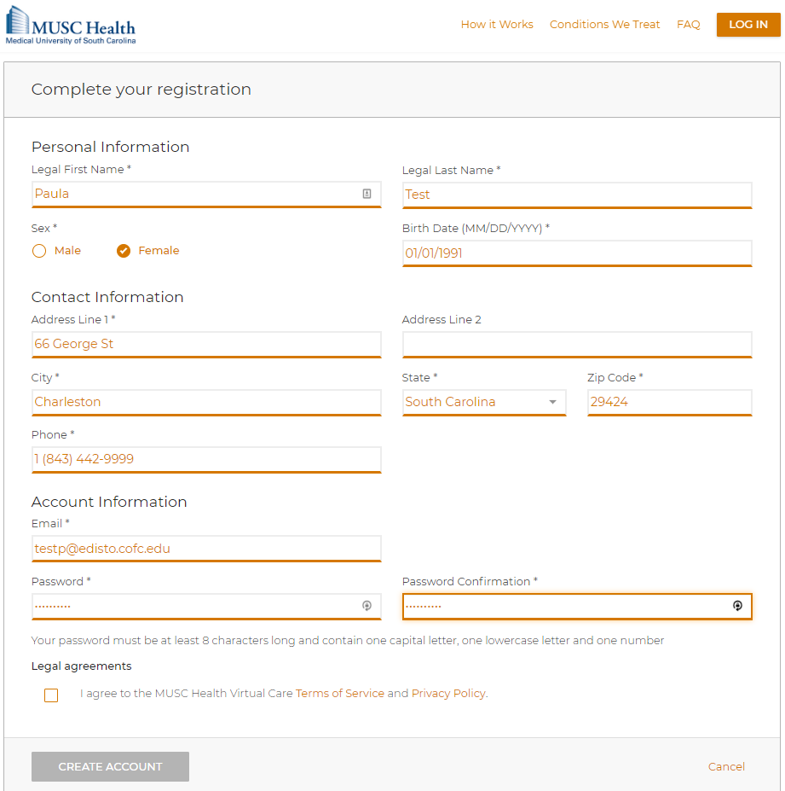
- The next screen prompts you for your demographic information. Complete all of the fields. Acknowledge the Legal agreements, then click Create Account.

- A confirmation email will be generated and sent to the email used for registration.
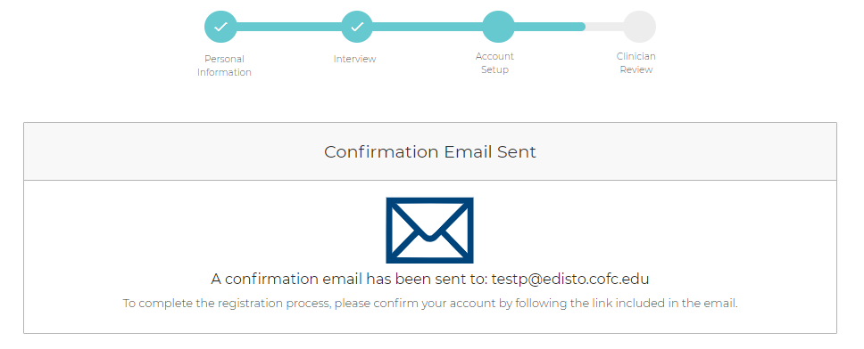
- Check your email and click on the link of the confirmation to confirm your MUSC Virtual Health account.

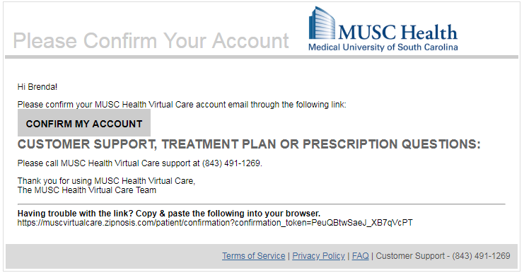

Your account has now been created! You are now ready to start your visit!

Please call 843-474-1920 with any questions or concerns related to setting up your account.
For general COVID-19 questions, please call 843-985-8888.

Steps to Complete an Online Screening in MUSC Health Virtual Care

- Navigate to musc.care
- This will launch MUSC Health Virtual Care.
- Login.

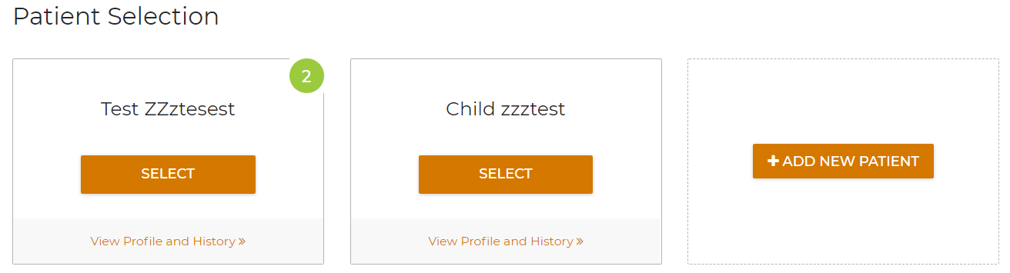
- Select the appropriate patient for the virtual visit.

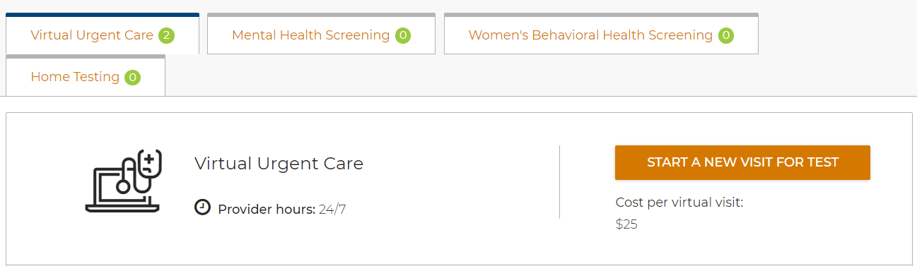
- Select Virtual Urgent Care and then “Start a New Visit”.

- Agree to the MUSC Health Terms of Service and Privacy Policy and acknowledge the Informed Consent and Terms of Use.
  - Click Continue.

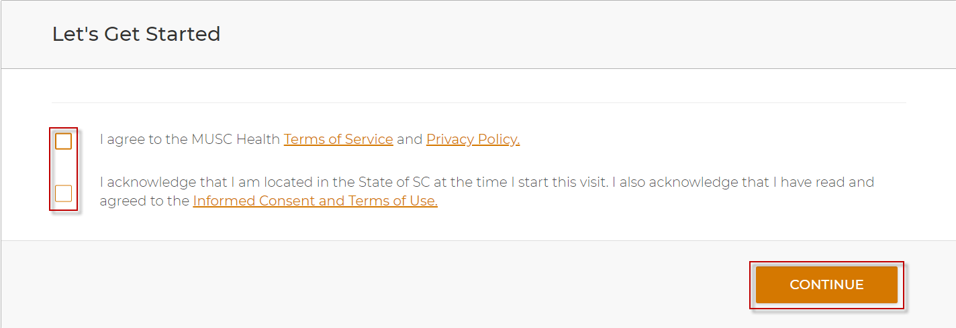

- Indicate if you have a serious health problem.
  - Click continue.

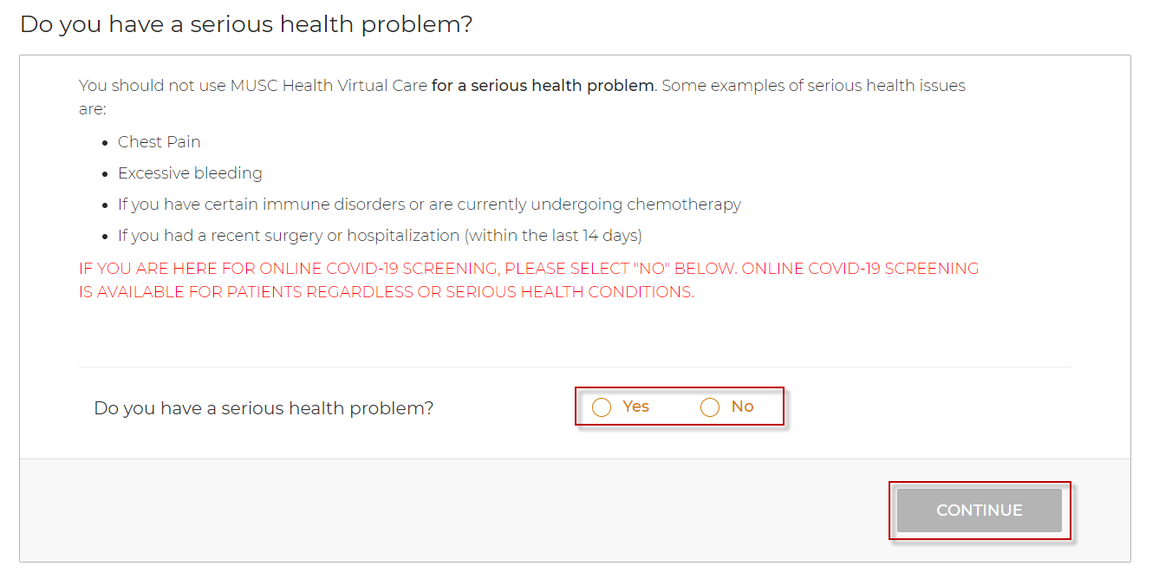

- Select the drop-down box that relates to the reason for the visit.
  - Click on the appropriate visit type to begin your encounter.

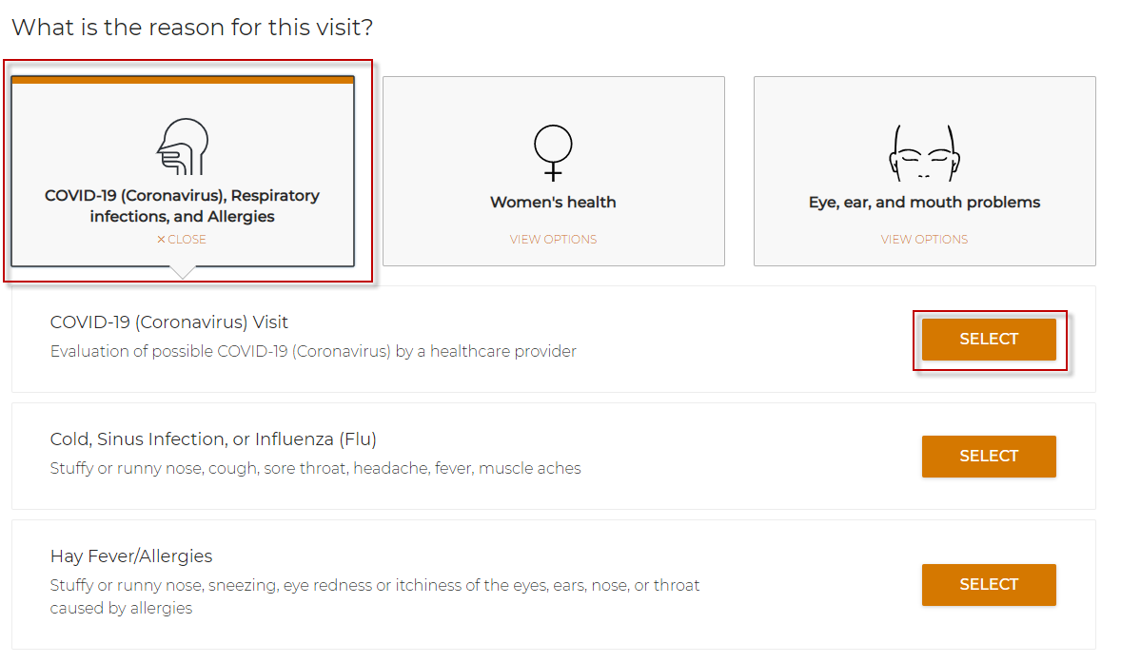

- Once you complete your encounter, route to the provider for review.
  - Following the provider’s review and assessment, you will receive an email informing you that the encounter summary is available via the musc.care portal.
  - Closely follow any instructions you receive from the provider.

Information on Covid Testing and Vaccination

If your MUSC provider has identified you as a person who may be at risk of infection with COVID-19 and testing is indicated, please schedule your test by clicking the link below and follow all instructions. This link will direct you to the different COVID-19 testing sites available and answer common questions. If you have any issues with online COVID-19 scheduling, please call the scheduling department at 843-876-7227.
Link to information on Covid Testing/Scheduling: https://muschealth.org/patients-visitors/coronavirus-information/covid-19-testing

If you would like information regarding the COVID-19 Vaccination, please click on the link below.
https://muschealth.org/get-vaccine

